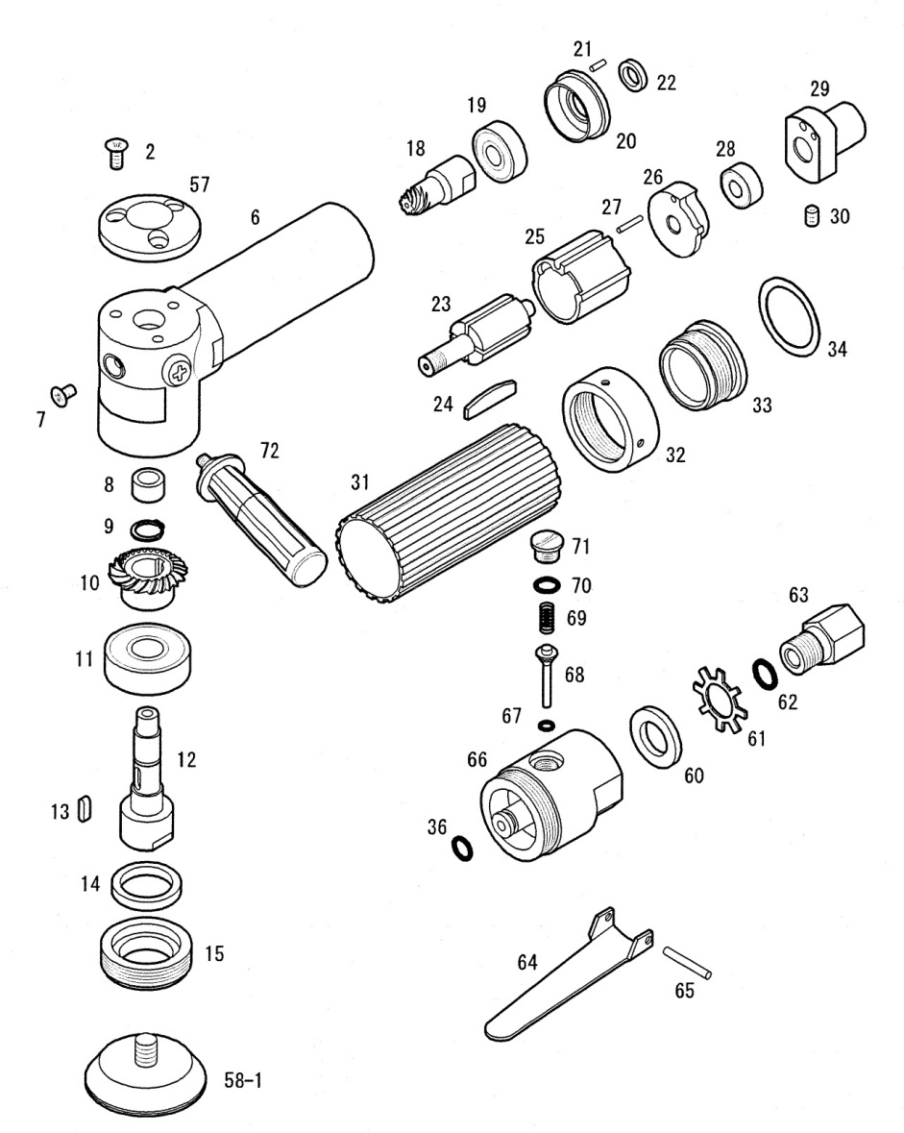

**GP3830K**

**Lustreuse Ø75**

|  |  |  |  |  |  |  |  |
| --- | --- | --- | --- | --- | --- | --- | --- |
| rep | Ref | DESCRIPTION | Qté | rep | Ref | DESCRIPTION | Qté |
| 2 | GP3830K-02 | Vis | 3 | 30 | GP3830K-30A | Vis | 1 |
| 6 | GP3830K-06 | Corp | 1 | 31 | GP3830K-31A | Gaine | 1 |
| 7 | GP3830K-07 | Vis | 1 | 32 | GP3830K-32A | Ecrou | 1 |
| 8 | GP3830K-08 | Roulement aiguilles | 1 | 33 | GP3830K-33A | Contre écrou | 1 |
| 9 | GP3830K-09 | Circlips | 1 | 34 | GP3830K-35A | Rondelle | 1 |
| 10 | GP3830K-10 | Couronne | 1 | 36 | GP3830K-36A | Joint | 1 |
| 11 | 6201-2RS | Roulement 6201 | 1 | 57 | GP3830K-57 | Capot tête | 1 |
| 12 | GP3830K-12 | Arbre | 1 | 58-1 |  | Plateau Ø75 | 1 |
| 13 | GP3830K-13 | Clavette | 1 | 60 | GP3830K-60 | Silencieux | 1 |
| 14 | GP3830K-14 | Joint | 1 | 61 | GP3830K-61 | Etoile | 1 |
| 15 | GP3830K-15 | Bague de serrage | 1 | 62 | GP3830K-62 | Joint | 1 |
| 18 | GP3830K-18 | Pignon | 1 | 63 | GP3830K-63 | Raccord | 1 |
| 19 | 608-2RS | Roulement 608 | 1 | 64 | GP3830K-64 | Gâchette | 1 |
| 20 | GP3830K-20 | Flasque avt | 1 | 65 | GP3830K-65 | Goupille | 1 |
| 21 | GP3830K-21 | Goupille | 1 | 66 | GP3830K-66 | Bloc valve | 1 |
| 22 | GP3830K-22 | Entretoise | 1 | 67 | GP3830K-67 | Joint | 1 |
| 23 | GP3830K-23 | Rotor | 1 | 68 | GP3830K-68 | Valve | 1 |
| 24 | GP3830K-24 | Palette | 4 | 69 | GP3830K-69 | Ressort | 1 |
| 25 | GP3830K-25 | Chemise | 1 | 70 | GP3830K-70 | Joint | 1 |
| 26 | GP3830K-26 | Flaque arr | 1 | 71 | GP3830K-71 | Ecrou | 1 |
| 27 | GP3830K-27 | Goupille | 1 | 72 | GP3830K-72 | Poignée | 1 |
| 28 | R4-2RS | Roulement R4ZZ | 1 |  |  |  |  |
| 29 | GP3830K-29 | Couvercle moteur | 1 |  |  |  |  |