



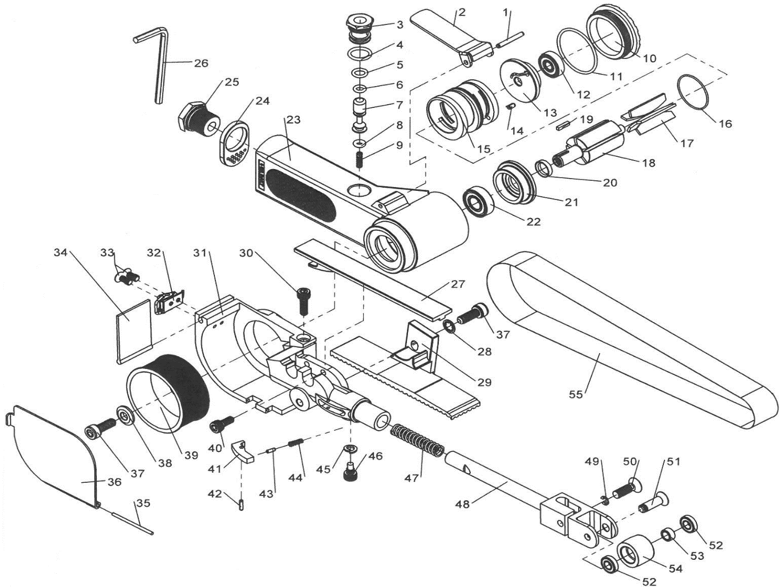

**GP4814**

**Ponceuse à bande 20x520**

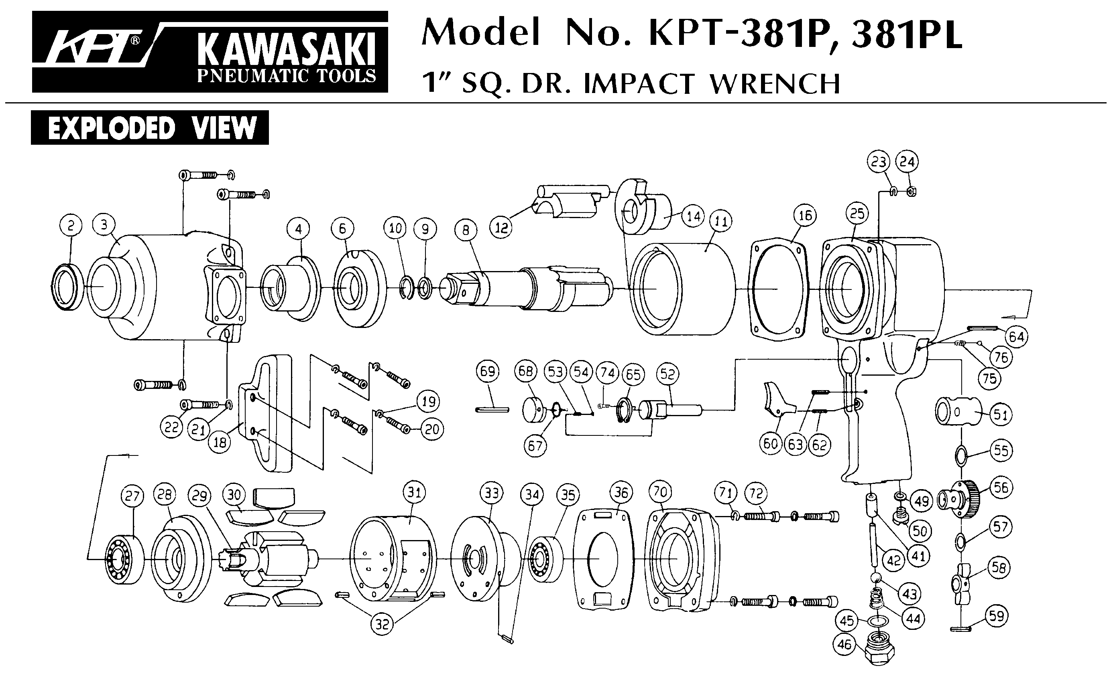





|  |  |  |  |  |  |  |  |
| --- | --- | --- | --- | --- | --- | --- | --- |
| Rep | Ref | Description | Qté | Rep | Ref | Description | Qté |
| 1 | GP4814-30 | Goupille | 1 | 29 | GP4814-46 | Protection | 1 |
| 2 | GP4814-29 | Gâchette | 1 | 30 | GP4814-11 | Vis | 1 |
| 3 | GP4814-31 | Chemise valve | 1 | 31 | GP4814-13 | Corps support bras | 1 |
| 4 | GP4814-32 | Joint | 1 | 32 | GP4814-48 | Verrou | 1 |
| 5 | GP4814-33 | Joint | 1 | 33 | GP4814-50 | Vis | 2 |
| 6 | GP4814-34 | Joint | 1 | 34 | GP4814-12 | Bavette | 1 |
| 7 | GP4814-35 | Axe valve | 1 | 35 | GP4814-51 | Goupille | 1 |
| 8 | GP4814-36 | Joint | 1 | 36 | GP4814-49 | Carter protection bande | 1 |
| 9 | GP4814-37 | Ressort | 1 | 37 | GP4814-44 | Vis (=GP4814-8) | 1 |
| 10 | GP4814-23 | Capot moteur | 1 | 38 | GP4814-8A | Rondelle | 1 |
| 11 | GP4814-53 | Joint chemise moteur | 1 | 39 | GP4814-9 | Poulie d’entraînement | 1 |
| 12 | 626-2RS | Roulement 626 | 1 | 40 | GP4814-6 | Vis | 1 |
| 13 | GP4814-25 | Flasque arr | 1 | 41 | GP4814-14 | Pate | 1 |
| 14 | GP4814-26A | Goupille | 1 | 42 | GP4814-17 | Goupille (=GP4814-51) | 1 |
| 15 | GP4814-26 | Cylindre | 1 | 43 | GP4814-16 | Goupille | 1 |
| 16 | GP4814-52 | Joint carter moteur | 1 | 44 | GP4814-15 | Ressort | 1 |
| 17 | GP4814-27 | Palette | 5 | 45 | GP4814-5A | Rondelle | 1 |
| 18 | GP4814-28 | Rotor | 1 | 46 | GP4814-5 | Vis | 1 |
| 19 | GP4814-22 | Clavette | 1 | 47 | GP4814-3 | Ressort | 1 |
| 20 | GP4814-21 | Entretoise | 1 | 48 | GP4814-1N | Bras | 1 |
| 21 | GP4814-20 | Flasque avt | 1 | 49 | GP4814-41A | Rondelle | 1 |
| 22 | R6-2RS | Roulement R6 | 1 | 50 | GP4814-41 | Vis | 1 |
| 23 | GP4814-18 | Corps moteur | 1 | 51 | GP4814-42 | Vis | 1 |
| 24 | GP4814-38 | Silencieux | 1 | 52 | 686-2RS | Roulement 686 | 2 |
| 25 | GP4814-39 | Raccord | 1 | 53 | GP4814-43 | Entretoise | 1 |
| 26 | GP4814-40 | Clé | 1 | 54 | GP4814-2N | Poulie | 1 |
| 27 | GP4814-10 | Guide bande | 1 |  | GP4814-18A | Manchon caoutchouc | 1 |
| 28 | GP4814-45 | Rondelle | 1 |  |  |  |  |