

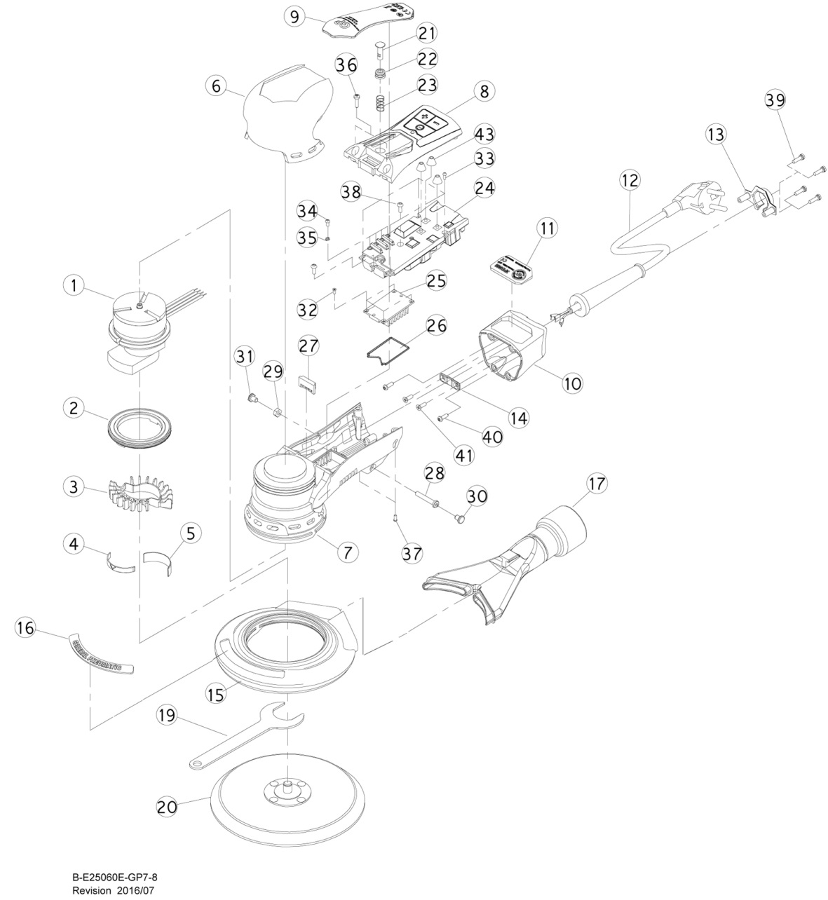

**XPE4648**

**Ponceuse électrique**

**Ø150**

|  |  |  |  |  |  |  |  |
| --- | --- | --- | --- | --- | --- | --- | --- |
| ref. | Rep | Désignation | Qté | ref. | Rep | Désignation | Qté |
| XPE4648-1 | 1 | Ensemble moteur (ex 2.5mm) | 1 | XPE4658-23 | 23 | ressort | 1 |
| XPE4658-2 | 2 | Ecrou moteur + joint (6,2-7,3Nm) | 1 | XPE4658-24 | 24 | Carte électronique (220v) | 1 |
| XPE4658-3 | 3 | Ailette de refroidissement | 1 | XPE4658-25 | 25 | Bloc thermique | 1 |
| XPE4658-4 | 4 | Petite entretoise ailette | 1 | XPE4658-26 | 26 | Joint | 1 |
| XPE4658-5 | 5 | Grande entretoise ailette | 1 | XPE4658-27 | 27 | Guide | 1 |
| XPE4658-6 | 6 | Grip poignée | 1 | XPE4658-28 | 28 | vis (M4x25 - 0,98Nm) | 1 |
| XPE4658-7 | 7 | Corp machine | 1 | XPE4658-29 | 29 | écrou (M4) | 1 |
| XPE4658-8 | 8 | Capot supérieur | 1 | XPE4658-30 | 30 | Cache vis | 1 |
| XPE4658-9 | 9 | Gâchette | 1 | XPE4658-31 | 31 | Cache écrou | 1 |
| XPE4658-10 | 10 | Capot du câble d'alimentation | 1 | XPE4658-32 | 32 | Vis (M2x5) | 4 |
| XPE4658-11 | 11 | Plaque rouge | 1 | XPE4658-33 | 33 | vis (M2x6) | 4 |
| XPE4658-12 | 12 | Cable d'alimentation | 1 | XPE4658-34 | 34 | Vis (M2,5x5 - 0,98Nm) | 4 |
| XPE4658-13 | 13 | Serre câble arr. | 1 | XPE4658-35 | 35 | Rondelle | 4 |
| XPE4658-14 | 14 | Serre câble Int | 1 | XPE4658-36 | 36 | Vis (M3x12 - 1,47Nm) | 2 |
| XPE4658-15 | 15 | Jupe | 1 | XPE4658-37 | 37 | Vis (M2x6) | 2 |
| XPE4658-16 | 16 | Plaque GP | 1 | XPE4658-38 | 38 | Vis (M3x8 - 0,98Nm) | 2 |
| XPE4658-17 | 17 | Sortie poussière | 1 | XPE4658-39 | 39 | Vis (M3x10 - 0,98Nm) | 4 |
| XPE4658-19 | 19 | Clé 24mm | 1 | XPE4658-40 | 40 | Vis (M3x10L - 1,17Nm) | 2 |
| XPE4658-20 | 20 | Plateau | 1 | XPE4658-41 | 41 | Vis (M3x10 - 1,98Nm) | 2 |
| XPE4658-21 | 21 | Commande gâchette | 1 | XPE4658-43 | 43 | Bouton | 3 |
| XPE4658-22 | 22 | Protection commande | 1 |  |  |  |  |